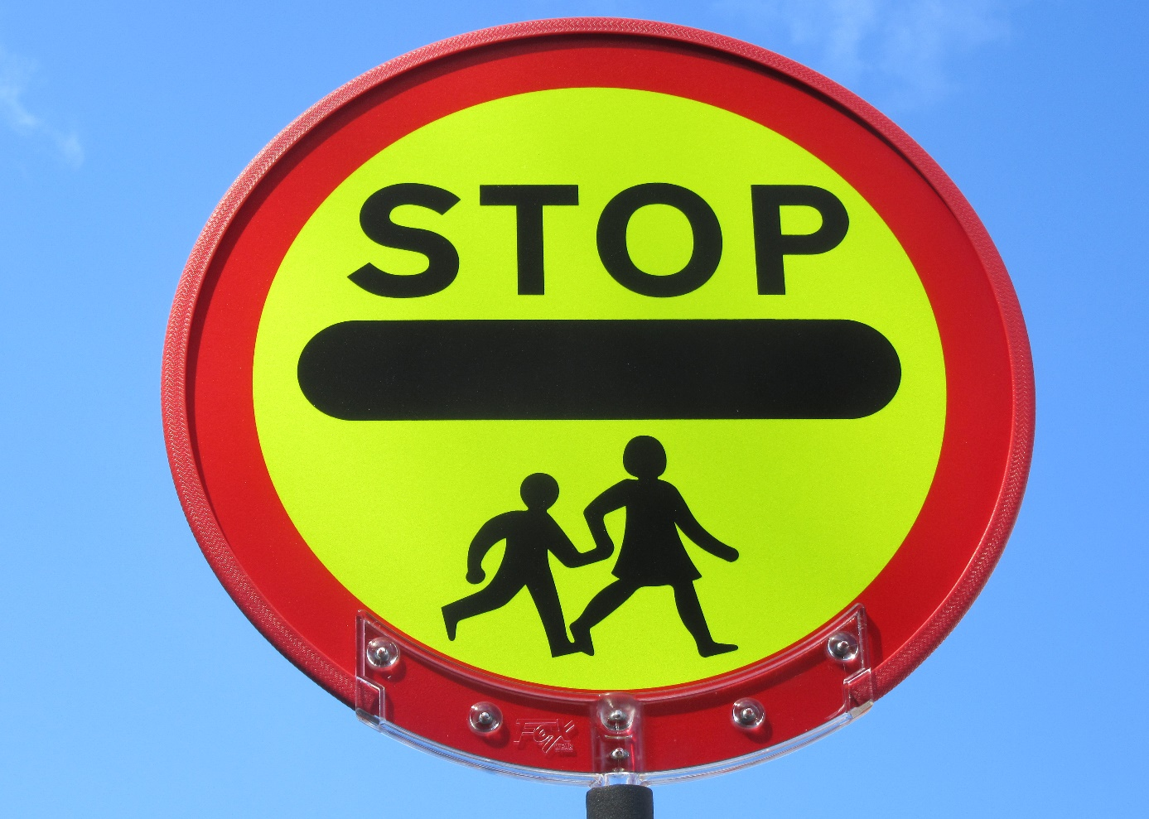

School Crossing Patrol needed at
Rose Green Junior School
(Located Carlton Drive/Rose Green Road)
8.15am – 8.50am and 15.00 - 15.30pm.

West Sussex County Council employs a large team of dedicated men and women who assist children across busy roads. This is a great opportunity to play a key role in your community.

Using specific procedures and after full training, you will control traffic and pedestrians, including young children and their parents, every school day.

Benefits include regular monthly pay, full training, uniform provided free and an opportunity to work at West Sussex County Council. Successful candidates will be subject to a DBS background security check and medical assessment.

For more information and to complete your application go to
westsussex.gov.uk/jobs/search-for-a-job

and search for School Crossing Patrol. If you are unable to apply online or have further questions please contact the Area Co-ordinator, Caroline Martin, on 07775 502874.

