Keep yourself ‘Safe Against Scams’ with free webinars

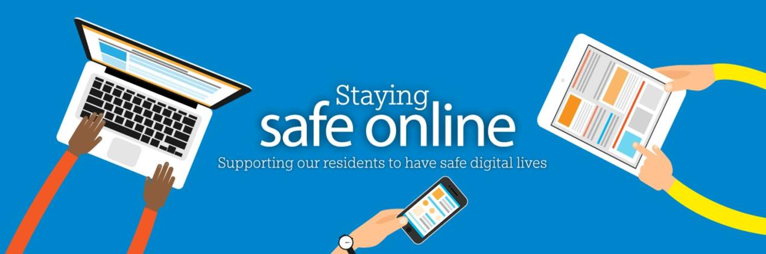
Over the next three months, the West Sussex Community Safety & Wellbeing Team are working with West Sussex Trading Standards to offer residents free online webinars to help keep themselves ‘Safe Against Scams’.
These hour and a half sessions have been organised as the county has seen a rise in a number of different scams, including telephone, courier and romance fraud.
Not only do these scams have a financial impact on victims, they also have an emotional impact which can often be just as damaging.
Francesca Blow, Lead for Safe Digital Life at the County Council, said: “More than ever before, people across West Sussex have been relying on technology to enable them to work, learn and connect with each other. Inevitably, criminals have exploited and used our increased digital lives to their advantage.
“Working alongside our Trading Standards Team has helped us to create a really great session which we hope will teach attendees how to spot a scam, what to do if their friends or their family become a victim and generally to help raise awareness of the different types of fraud that are doing the rounds here in West Sussex.”
Richard Sargeant, Trading Standards Team Manager at the County Council, said: “Since the pandemic started there has been a significant rise in reports from members of the public who have been affected by telephone and online scams.
“As a team, we are always looking for opportunities to raise awareness, so it has been great to work with Francesca and her team to help teach people how they can stop fraudsters before they can have a detrimental effect on somebody’s life.”
The dates for the free sessions are:
- Thursday 20 May 10am – 11.30am
- Thursday 20 May 6pm – 7.30pm
- Tuesday 15 June 10am – 11.30am
- Tuesday 15 June 6pm – 7.30pm
- Tuesday 27 July 10am – 11.30am
- Tuesday 27 July 6pm – 7.30pm
If you’re interested in signing up for one of the free webinars, visit Eventbrite and search for ‘Safe Against Scams’ to book your place.
​

For further information please contact the news desk on 0330 222 8090 or email pressoffice@westsussex.gov.uk.
For urgent out-of-hours enquiries please call 07767 098415.

